New features in Mother 0.6:
- Small mistakes fixed from previous 0.5 release
  - Waltz synth example was not working.
  - I failed to mention in the documentation that you also need the Shapetween library to develop new synths.
- More comprehensive secondary screen support introduced.
- pre(), draw(), post() and dispose() methods are now called properly in synth libraries.
- It is no longer necessary to put an Init() method in sketches intended as Synths for Mother (Finally!).

Mother 0.6 Usage instructions
Mother is a standalone host application for running multiple Processing sketches in parallel, and mixing their output, in a manner analogous to VJing. Version 0.6 has been tested with processing version 1.0.9, and might not work with sketches exported with earlier/later versions of Processing.

For a Processing sketch to be compatible, it needs to have been built using the Foetus library provided.

To create a synth for use with Mother, use the Foetus library, export it from the processing environment, and place the resulting .jar file, and the .jar files of any libraries used, in the synth folder specified in the mother.ini file. Further instructions on how to create a synth for use with Mother follow in a separate section.

Start-up settings for Mother:
In the mother.ini file, located in the same folder as the Mother executable, the following start-up parameters can be specified. # denotes a comment. Make sure to write all lines without any spaces!

# This is where the host looks for the synth jar files.
# the folder you point to needs to also include two subfolders, "data" and "libraries".
# So if you keep your synths in "X:\\Synths", you also need to create folders
# "X:\\Synths\\data", and "X:\\Synths\\libraries".
SynthFolder=X:\\Lumia Synths;

# Here the IP address of the OSC controller is specified.
IP=127.0.0.1;

# The port on which the host receives OSC messages.
osc_receive_port=7005;

# The port to which the host sends OSC messages.
osc_send_port=5432;

# If the host should run in fullscreen, set this parameter to 1. For windowed mode set the # parameter to 0.
FullScreen=0;

# Setup secondary display output to use when in fullscreen mode.
# 0: primary display,
# 1: secondary display.
# n: n-th display (untested).
outputScreen=0;

screenSize=640,480;

# Framerate:
frameRate=24;

# Path for storing screen captures:
imagePath=D:\\Mother grabs - Dirty\\;

# Fraction of running speed. So if framerate is 30, and fraction is 5, the actual framerate # will be 6 fps. This is useful when running mother in non-realtime, and recording the # output to image files. The fraction value is then used to adjust timing calculations so # that the rendered sequence corresponds perfectly to what it would have looked like in # real time.
speedFraction=1;

OSC Messages for Mother:

/Mother/Get_synth_names
Causes a message to be returned containing the names of all the synth types that the host has access to, in the following format:

/Synth_names synth1 synth2 synth3 (…)

/Mother/Add_synth synth1 synth1_01
To add a synth at the topmost layer, the /Mother/Add_synth message needs to be sent with two arguments, the name of the desired synth type, and a unique name to identify the particular synth instance. If an instance already exists with that name, no new synth is added to the stack.

/Mother/Remove_synth synth1_01
Removes the synth with the ID specified in the argument. If no synth is found with that ID then no synth is removed.

/Mother/Move_synth synth1_01 0
The synth specified in the first argument is moved to the stack location specified in the second argument. The synth that previously held that location is displaced.

/Mother/Record 1
If 1 is specified, Mother begins recording .png images to the path specified in the “imagePath” field of mother.ini. A message with value 0 stops the recording. Only for use in non real-time mode, as it is normally too demanding to run in real-time.

(/Mother/Set_synth_blending synth1_01 Source Destination)
Deprecated! The way this was implemented was too costly in terms of performance for it to be worth keeping. If different blending modes are desired, you can easily implement that within your synths.

(/Mother/Set_synth_color synth1_01 R G B A)
Deprecated! The way this was implemented was too costly in terms of performance for it to be worth keeping.

Messages for Foetus:
Each synth has to be built using the Foetus library. Besides enabling a Processing sketch to work with the host, the library also enables the synth to communicate over OSC. The foetus library itself only responds to one message, which in turn returns a message with all the additional OSC messages the synth supports, along with their typetags:

/Mother/Child/synth1_01/Get_Supported_Messages

Where synth1_01 is the ID of a synth of the desired type.

The returned message is then of the following format:

/Synth_supported_messages/synth1_01 /Param_3 ii /Param_2 ii /Param_1 ii

Where the address of each parameter followed by its typetag are listed in turn.

The parameters of each synth are then addressed using messages using the following format:

/Mother/Child/ synth1_01 /Param_Name

Foetus methods:
Well it only has one as of yet ☺
millis() is the same as the Processing millis() function, with the additional feature that it takes the specified speed fraction into account. This is useful when running in non real-time mode, as the f.millis() call returns the time value at a given frame number that it would have if it were running in real-time.

Building a synth using Processing:
- Install and include the Foetus library into your processing environment.

- If you do not already have them, also install the OSCP5 library and the Shapetween library, as the Foetus library depends on them.

- Make sure you use the OPENGL-renderer, as the P2D and P3D renderers are unsupported.

- Declare a public foetus object named f: public Foetus f;

- Create a method void initializeFoetus(). This method will hold all your initialization code. Setup() is not called when a sketch is used as a synth in Mother, and so any initialization you would normally do in Setup(), should instead be performed here.

- Call initializeFoetus() from within setup() (or running the sketch outside of Mother will not be possible).

- In initializeFoetus(), instantiate the foetus object: f = new Foetus(this);

- Export the applet using the File->Export option. Out of the resulting folder, you need to copy the .jar file with the name of the sketch into your synth folder, as it has been defined in the mother.ini file. You also need to copy the .jar files that your synth depends on.

(optional) If you want the synth to respond to its own set of OSC messages:

- register what these messages are in the initializeFoetus() method:

f.registerMethod("/TopColor ", "iii");
f.registerMethod("/BottomColor ", "iii");
etc…

- and add a void oscEvent(oscMessage theOscMessage) method:

void oscEvent(OscMessage theOscMessage)
{
if (theOscMessage.checkAddrPattern("/TopColor") == true)
{
/* check if the typetag is the right one. */
if (theOscMessage.checkTypetag("iii"))
{
m_TopR = theOscMessage.get(0).intValue();
m_TopG = theOscMessage.get(1).intValue();
m_TopB = theOscMessage.get(2).intValue();
return;
}
}
else if (theOscMessage.checkAddrPattern("/BottomColor") == true)
{
etc…
}

Spline interpolation:
With Mother 0.2 came the facility of allowing spline interpolation for individual floating point synth parameters. Instead of declaring each parameter as float, you declare it as FoetusParameter, and instantiate it in the initializeFoetus() method, eg:

Declaration:
Foetus parameter m_Red;

Instantiation:

initializeFoetus()
{
…

// Instantiate foetus object here
f = new Foetus(this);

m_Red = new FoetusParameter(f, 0, "/Red","f");

…
}

Where f is a reference to the Synth’s Foetus (make sure to first instantiate it before using it here or the synth will crash!), 0 is the initial value, “/Red” is its OSC address, and “f” is the OSC typetag. With the 0.2 release the only supprted typetag is “f”, but I’ve nonetheless added the parameter for compatibility with future releases.
If you use FoetusParameter, you do not need to use f.registerMethod() for it, as this is taken care of from inside the constructor.

You then get the interpolated value using the getValue() method, and set their value using setValue().

At the moment, the speed of the interpolation is the time that passed between the two previous setValue() calls, or three seconds, whichever is the shortest.

If messages are received with intervals shorted than 100 milliseconds, no interpolation is done between them.

Also note that no possibility to control the spline interpolation has been added, though that is planned for a future release. The default setting used is that of an ‘S’ curve, which gives the most natural-looking type of animation:

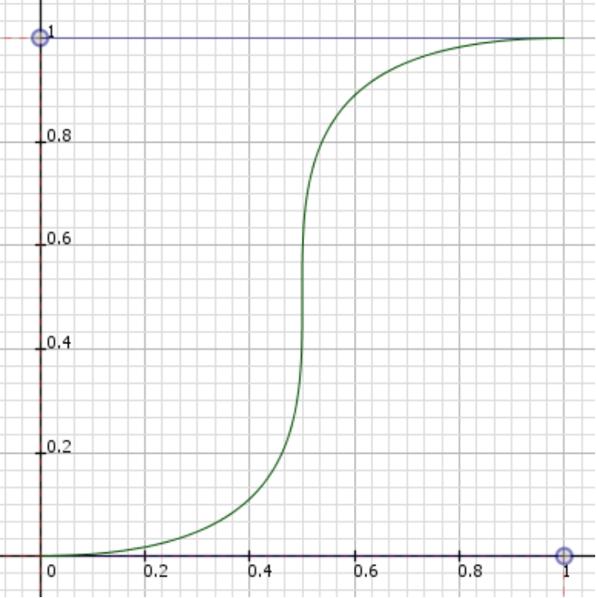

Keep in mind though that spline interpolation is relatively expensive computationally, if you use it on a very large number of parameters it may end up affecting the frame-rate of the sketch.

Finally note that all included examples have been updated for version 0.2, and to use spline interpolation, so have a look to see how it is done, there is very little to it!

Notes on using multiple screens:
While running Mother on a computer with more than one display device attached may be desirable, it does also mean that certain complications need to be taken into consideration. Not all graphics cards are good at supporting OpenGL acceleration on the secondary display, and even those at are, often do so at the cost of reduced performance. So although Mother supports outputting to the secondary display, I strongly recommend setting your projector to be your primary display, and disabling OpenGL acceleration on the secondary, for maximized OpenGL performance.

Suggestions for advanced users:
Mother is most intuitively used from within the Eclipse IDE, as you then have access to the console, and can see the stack trace in case your sketch has crashed while running within Mother. I therefore recommend downloading the Mother source code and setting up a project in eclipse for it.

Another useful tip when running from within Eclipse is to reference your synth projects from the Mother project (Mother->Properties->Java build path->Projects->Add...). This way, you do not need to export the .jar file for your synth every time you’ve made a change to it, instead Mother will use the code for the synth as is referenced from within Eclipse.

Revision history:

Mother 0.5:
- Updated Mother to use Processing 1.0.7
- Performance improved
- Stability improved (bugs fixed)
- OSX-port implemented (Many thanks to Krzysztof Goliński and Splatgirl for their work on the port!)

Mother 0.4:
- Updated Mother to use Processing 1.0.5.
- Updated the distribution to conform to the Processing Library guidelines.
- Added Pure Data controller example.

Mother 0.3:
- Anti-aliased rendering, a very important feature which has improved image quality considerably.
- Support for Processing version>1.x
- A more straightforward way of handling sketches which use external libraries. In previous versions libraries had to be packed in the jar file of the sketch. Now libraries are loaded dynamically when needed from their original jar files, so all a user needs to do is place all library jar files in a designated folder.
- Non real-time mode, useful for rendering high resolution video to disk.
- Considerable speed increases through various optimizations.

Mother 0.2:
- Spline interpolation
- Bug fixes

